Dynamic Message Signs
Operational Guidelines
For NDOT District II
2008
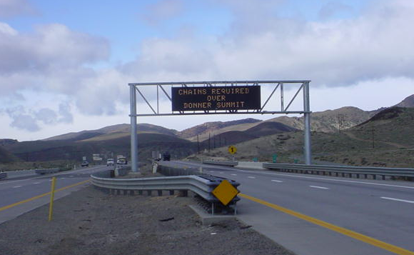

TABLE OF CONTENTS

List of DMS………………………………………………………………………………………...…... 2

Concept of Operations …………………………….……………………………………………………. 3

Message Priority Levels and Samples ……………………………………………………………………3

Protocol and Contacts ……………………….………...……………………………………………….. 6
Definitions: Standard vs. Non-Standard Messages
Requests
Authority to create & display
Message Template …………………………………….………………………………………………… 7
Acceptable Abbreviations
Dual Frame Messages ………………………………………………………………………………….. 9

General Weather Related Messages ……………………………………………………………………. 9

Portable DMS Placement Guidelines ……..……………………………………………………………. 9

Maintenance ……….…………………………………………………………………………………… 10

SAMPLE MESSAGES ….…………………………………………………………………….. 10

DMS List

The sign locations & display sizes are listed below in table 1 and shown in Figure 1.

 | District 2 Dynamic Message Signs,
Name | Make/size | Route | Dir | Milepost | Characters / Line
Mustang'* | Daktronics 1 | I-80 | W/B | WA 24.00 | 18 / 3
'Cemetery'* | Daktronics 1 | I-80 | W/B | WA 11.58 | 18 / 3
Mogul'* | Daktronics 1 | I-80 | W/B | WA 7.00 | 18 / 3
'College'** | Daktronics 1 | US-395 | N/B | CC 7.40 | 18 / 3
'Stateline' | Daktronics 2 | US-50 | E/B | DO 0.57 | 12 / 3
'Kahle' | Daktronics 2 | US-50 | W/B | DO 1.10 | 12 / 3
'Foothill' | Daktronics 2 | SR-207 | N/B | DO 11.01 | 12 / 3
'Stead' | Skyline 1 | US-395 | S/B | WA 33.44 | 17 / 3
'Neil' | Skyline 1 | I-580 | N/B | WA 20.28 | 17 / 3
'Damonte'** | Skyline 1 | I-580 | S/B | WA 17.41 | 17 / 3
'Boomtown' | Skyline 1 | I-80 | E/B | WA 5.58 | 17 / 3
'Stoker' | Skyline 1 | I-80 | E/B | WA 11.56 | 17 / 3
'Vista' | Skyline 1 | I-80 | W/B | WA 19.20 | 17 / 3
'Mt Rose' | Daktronics 2 | SR-431 | S/B | WA 21.90 | 12 / 3
Incline' | Sylvia 2 | SR 431 | N/B | WA 2.60 | 15 / 2
'Spooner' | Daktronics 2 | US-50 | W/B | CC 7.50 | 12 / 3
'Arrowhead'** | Daktronics 2 | SR-529 | N/B | CC 5.55 | 12 / 3
Winters Ranch'** | Daktronics 2 | US-395 | S/B | WA 7.42 | 12 / 3
"5th St'** | Skyline 1 | US-395 | N/B | CC 4.32 | 17 / 3
"Fernley W/B' | Daktronics 1 | I-80 | E/B | LY 0.73 | 18 / 3
"Fernley E/B' | Daktronics 1 | I-80 | W/B | LY 0.73 | 18 / 3
"Trinity' | Daktronics 1 | I-80 | W/B | CH 23.46 | 18 / 3
"Nightingale' | Daktronics 1 | I-80 | E/B | CH 7.86 | 18 / 3
"Humboldt' | Daktronics 1 | I-80 | W/B | PE 49.79 | 18 / 3
"Jacks Valley" | Daktronics 1 | US-395 | S/B | DO 33.45 | 18 / 3
"Mueller" | Daktronics 1 | US-395 | N/B | DO23.72 | 18 / 3
"Holbrook N/B" | Daktronics 2 | US-395 | N/B | DO 3.72 | 12 / 3
"Holbrook S/B" | Daktronics 2 | US-395 | S/B | DO 3.72 | 12 / 3
"95 TrinityN/B" | Daktronics 2 | US-95 | N/B | CH 58.56 | 12 / 3
"95 Trinity S/B" | Daktronics 2 | US-95 | S/B | CH 58.56 | 12 / 3
"Hawthorne N/B" | Daktronics 2 | US-95 | N/S | MI 51.98 | 12 / 3
"Hawthorne S/B" | Daktronics 2 | US-95 | S/B | MI 51.98 | 12 / 3
"Luning N/B" | Daktronics 2 | US-95 | N/B | MI 24.48 | 12 / 3
"Luning S/B" | Daktronics 2 | US-95 | S/B | MI 24.48 | 12 / 3
"Schurz N/B" | Daktronics 2 | US-95 | N/S | MI 82.58 | 12 / 3
"Schurz S/B" | Daktronics 2 | US-95 | S/B | MI 82.58 | 12 / 3

Table 1 – Sign Locations

* For operation of DMS on the Westbound Interstate 80 corridor, these guidelines have also been adopted by CALTRANS to provide continuity
** Wind Signs the 5 DMSs used for Washoe Valley wind (Damonte s/b on I-580 and 5th Street n/b on US50/US395 only for PROHIBTIONS) should also be used for R-1 conditions, or other messages, as needed when there are no wind messages to display. Only when you believe the R-1 message will interfere with the wind-triggers should it not be displayed. Wind is the primary use of the 3 signs.

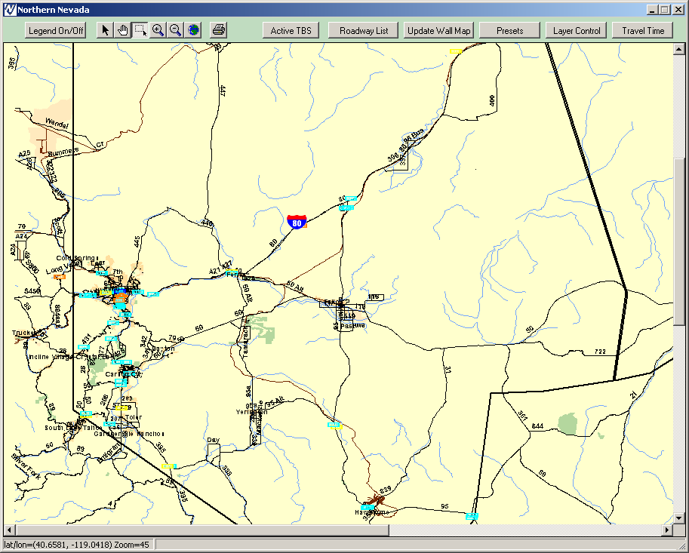
Figure 1 - Sign Locations

Concept of Operations

The primary purpose of Dynamic Message Signs (DMS) is for alerting motorists to current travel conditions that are unexpected or have changed recently. The signs can only convey limited information to drivers. (More detailed en-route traveler information is available to the driver using the 511 Phone System and/or Highway Advisory Radio)

Sudden or unexpected changes in travel conditions may include the following:

- Crashes  - Disabled Vehicle  - Controls/Restrictions  - Special event traffic  - Maintenance activities (road work, snow removal operations, debris pickup) | - Construction  - Congestion/queue  - Sudden change in weather (heavy rain, fog, heavy snow, high winds, flooding)

DMS are also used to support:
- Amber Alert program
- Various Public-Service Announcements or “PSA” campaigns (these are the lowest priority messages)

Message Priority

Message priorities have been developed to insure that the most critical messages are displayed when requests for different messages occur simultaneously. Do not use two pages to display two different messages. Higher priority messages shall take precedence over lower priority messages and shall remain on the DMS until no longer current. In the event that simultaneous message requests are of the same priority, events located closest to the sign shall take precedence. Incidents on Interstate take priority over incidents on State Routes.

Priority Levels from high to low:

Level 1 Current road condition information; road closures, lane restrictions, controls/restrictions, emergency conditions
Level 2 AMBER Alert messages
Level 3 Non-critical traffic information (e.g. “FOOTBALL TRAFFIC TAKE EXIT 25”)
Level 4 Future road conditions information such as lane restrictions and road closures due to scheduled construction or events
Level 5 Public Service Announcements (PSA): (e.g. CLICK IT OR TICKET”)

When possible, DMS messages should provide reference location or information by distance or exit numbers (i.e. 10 miles or Exit 7) for motorists unfamiliar with the region. Do not use Mileposting.

For long work zones and queues associated with an incident, DMS messages should provide both the beginning and end location so local commuters can decide whether to use an alternate route.

In general, no traffic should be diverted off freeways, except when the freeway is actually closed. When diversion is necessary in urban areas, avoid DMS messages that divert traffic using a specific alternate route. Those specific alternate routes, when possible, should be state routes.
An incident located on the same roadway as the DMS should take priority over a similar incident on an adjacent or intersecting roadway. The distance between an incident and a posted DMS should be less than 25 miles. However, closures or incidents with a significant impact to traffic on an Interstate or US route require additional warning beyond 25 miles away if signs are available.

A frame, panel, or phase, all refer to the same capability of a DMS to display alternating “pages” of information under the same message. No more than 2 frames or “pages” should be used for permanent signs or portable trailer-mounted signs. Both pages should pertain to the same message, i.e. do not mix messages unless authorized.

NDOT prohibits the display of advertising messages on any DMS. Messages related to special events should use generic terms describing event (i.e. Football, Festival, Auto Race, Flea Market, etc.) and not the event sponsor (i.e. Hot August Nights, Nevada Wolf Pack, etc.), unless supported by static signing and improves driver recognition about the event.

For liability reasons, road specific messages using words such as “hazard” or “danger” (eg, “Shoulder Hazards Ahead . . . ”) are not allowed.

Advance notice of roadwork or special event should not be displayed more than six (6) days before the roadwork or special event.

Protocol & Contacts

The District Traffic Engineering Office provides overall guidance and direction regarding DMS operation, wording and use. Currently, NDOT’s Northern Nevada Road Operations Center Staff
(and Caltrans for W/B I-80) operate the permanent DMS 24 hours a day, 365 days a year.
NNROC Staff must be aware of established protocol for creating and displaying messages.

Due to the unlimited variation in unexpected events on the roadways, Dispatchers must also use sound judgment in determining appropriate message content and when to involve the Traffic Engineer in decision making. After posting a message, dispatchers shall monitor the situation to ensure that a message is updated or removed when appropriate.

Definitions:
Standard Messages: Those messages (or variations due to location) found in the Sign Libraries and referred to as “canned” messages. Messages for Wind in Washoe Valley, Controls/Restrictions, Roadwork, Congestion, Incidents, Closures and Public Service Announcements (PSA’s).

Non-Standard Messages: Messages not found in the Sign-Libraries. Messages requested from other than NDOT or Caltrans. Amber Alert Messages or other emergency alerts. Any message requiring specific reroute. Weather-related including snow, ice or visibility.

Requests:
All requests to display an immediate-need message should be directed to the NNROC at
(775) 834-8399. Requests for scheduled road-work (Standard Messages) should come from an NDOT Maint. Spvsr., R.E. or A.R.E.. Requests from other agencies for planned events or public informational messages should be directed to the District Traffic Engineer or the District Engineer via written form. Any message request, regardless of source, must adhere to the template specified in the “message template” section below.

Authority to create & display messages:

NNROC Staff has authority to create and display Standard Messages when the request comes from (or with approval of) NDOT personnel. The Maint. Spvsr. or Lead-man should be made aware of the message and exact wording.
Authority to create and display Non-Standard messages comes from NDOT-District Traffic Engineer, District Engineer or Assist District Engineer Maintenance as well as Caltrans for I-80 W/B DMS.

Contacts for approving Non-Standard Messages

Mike Fuess, District Traffic Engineer
Office: 834-8304 (or x 2604) Cell: 846-1587
Thor Dyson, District Engineer
Office: 834-8344 (or x 2601) Cell: 771-2341
Dave Titzel, A. D.E. Maintenance
Office: 834-8303 (or x 2603) Cell: 720-4525

Samples 1-PAGE messages from each priority level:

Priority Level 1


Road Closure

Lane Closure

Controls/Restrictions

***********************************************************************************
Priority Level 2

AMBER ALERT
***********************************************************************************
Priority Level 3
Event - Non-critical Road Info
***********************************************************************************
Priority Level 4

Future Road Info
***********************************************************************************
Priority Level 5

Winter Driving Safety

Seat Belt Campaign

Message template

The message template provides a means to display messages in a consistent manner. In general terms, all messages should inform drivers what caused or will cause the change in travel conditions (reason message is posted), where the change in travel conditions will be located, and what effect it will have on them. The message template is shown in Figure 2.

Figure 2 - Message Template

Table 4 illustrates specific applications of the message template:

Message Name | Line 1 | Line 2 | Line 3
Accident | CRASH | XX MILES AHEAD | XX LANE CLOSED
Road Closure | I80 WEST CLOSED | AT EXIT XX | USE ALT ROUTE
Road Work | ROAD WORK | XX MILES AHEAD | XX LANE CLOSED
Detour | DETOUR | XX MILES AHEAD | EXIT XX
Special Event | FOOTBALL TRAFFIC | USE EXIT XXX | DIAL 511 FOR INFO
Road Closed | I-80 CLOSED | FROM EXIT XX | TO EXIT XX
Chains or S-Tires | CHAINS OR SNOW | TIRES REQUIRED | 3 MILES AHEAD
Amber Alert | AMBER ALERT | WHITE FORD RANGER | NV 123 ABC

Table 4 – Message Template Applied

Some messages will direct the motorist where to obtain detailed traveler information, such as 511 Nevada or HAR. A second page (or panel) should be used for these circumstances. Refer to the dual frame section below.

Messages shall be specific to the greatest extent possible. For instance, if a lane closure will remain in the same lane one entire day, the message shall indicate which lane is closed, left or right, if the closure will change throughout the day, the message may simply indicate that one lane is closed.

Messages may be directed at all motorists or a specific audience. However, this needs to be clear to the motorist, e.g. “Turning Trucks X Miles Ahead”.

Notification of a weather related road condition should be posted at an adequate distance from weather to allow the motorist time to choose a course of action such as delaying travel, exiting the freeway, choosing an alternate route, etc. This is particularly important when advising truckers of a chain check before they are allowed to travel over the mountains. In this case it would be prudent to utilize both the DMS-1 (Mustang) and DMS-3 (Mogul) signs so the truckers without chains would have an area in which to exit the freeway before being backed up at the chain check area.

A road closure is different than a crash or lane closure. Information for road closures should contain detour information. In general, DMS messages direct the motorist to detour at a certain exit and use 511 or HAR to give information about detour routes. Detour routes may have static detour signs or law enforcement personnel giving positive guidance. If we instruct traffic to reroute onto a non-state route, we should advise the city or county with jurisdictional ownership.

In general, weather related conditions shall not be posted unless reported as severe or a significant change in travel conditions is expected, such as severe thunderstorm, heavy snow, severe icing or first winter weather event. All weather related roadway condition messages shall indicate severity (heavy or severe) and the distance ahead for which the condition applies. Any such message requires approval from the TE or ADE and shall be updated hourly or as conditions change.

Avoid Abbreviations when possible. However, many messages will require common abbreviations, especially portable DMS, such as those listed in Table 3 below.

Word | Abbreviation
Right | RT
Left | LT
Interstate XX | I-XX
Route | RTE
Road | RD
Mile(s) | Mi
Direction | N, S, E, W*
Alternate | ALT
Information | INFO
Exit | EXT*
Days of Week | MON, TUES, WED, THURS, FRI, SAT, SUN
Nevada | NV
California | CA
Utah | UT
Idaho | ID
Table 5 – Acceptable Abbreviations
* use only with a prompt word

Dual Frame Messages

To convey more information to the driver, it is sometimes necessary to display two frames rather than a single static frame. The second page is additional information to the first page and not a separate message. Dual frame messages should be avoided when possible because the dynamic display reduces the time a driver has to view each frame. There is also greater potential to confuse drivers. Messages consisting of more than two frames are not allowed. When a dual frame message is displayed, each frame should remain on for 2.0 seconds and off (between frames) for 0.3 seconds. Figure 6 below illustrates an acceptable 2-frame message to notify drivers of a recurring paving schedule.



Dual Frame Message

Weather Related Messages
Advisories, Watches and Warnings issued by the National Weather Service should be posted to the appropriate DMS in the corresponding map areas with an expiration time. Messages related to weather and road conditions, such as icy roads, blowing dust or fog may be used but must be monitored by the agency or crew making the request.

Weather Related PSA’s

DMS Failure

Each sign polls automatically every 10 minutes thru Central Systems Software to ensure the sign is operating properly. Refer to the Procedures Manual if a sign is not operating properly and troubleshooting tips, for the Wind Warning DMS, if after trying available troubleshooting tips and reporting DMS to Communication tech. and they cannot make repairs before needed, request Maintenance (C270) to place a portable DMS in a similar location, if conditions require the use of the portable. A portable DMS may be quicker to deploy than attempting to fix a permanent DMS. Portables should be checked before deploying at a site to ensure that connection is possible and the sign is operating properly.

SAMPLE DMS MESSAGES

Message Characteristics |  | Priority |  |  |  | Permanent DMS |  |  | Portable DMS
Road closure, limited detour information |  | 1 |  |  |  |  |  |  | CLOSED  5 MI  AHEAD
DETOUR
EXIT
19
Road closure, detour info given |  | 1 |  |  |  |  |  |  | I-80  CLOSED  EXIT 18
USE
MCCARRAN
EXIT 19
Road closure, other route, no detour info |  | 1 |  |  |  |  |  |  | I-80  CLOSED
EXT 14
TO
EXT 17
Road closure, detour info on HAR/511 |  | 1 |  |  |  |  |  |  | CLOSED  15 MI  AHEAD
INFO
DIAL
511
Road closure, detour |  | 1 |  |  |  |  |  |  | I-80  CLOSED
EXT 17
TO
EXT 14
USE
ALT
ROUTE
Lane closure, Accident |  | 1 |  |  |  |  |  |  | ACCIDENT  10 MI  AHEAD
RIGHT
LANE
CLOSED
Lane closure, Roadwork | 1 |  |  |  |  |  |  | ROADWORK  3 MI  AHEAD
Lane closure, Roadwork |  |  |  |  |  |  |  | LEFT  LANE  CLOSED
General Advisory,  snow | 1 |  |  |  |  |  |  | SNOWING  OVER DONNER
General Advisory,  snow |  |  |  |  |  |  |  | CARRY CHAINS
General Advisory, poor visibility | 1 |  |  |  |  |  |  | POOR  VISIBILITY  NXT 10 MI
General Advisory, Winter Weather, chains required | 1 |  |  |  |  |  |  | CHAINS MANDATORY  DIAL 511
General Advisory,  Chain check for truckers  These two signs should be used together when truckers are required to chain up over the pass. | 1  USE ON DMS-3 |  |  |  |  |  |  | TRUCK CHAIN CHECK  AT MOGUL
 | 1  USE ON DMS-1 |  |  |  |  |  |  | TRUCK CHAIN  CHECK 15MI  AHEAD
General Advisory, Snow Removal | 1 |  |  |  |  |  |  | CAUTION  SNOW REMOVAL
General Advisory, roadwork, DMS on same route as incident, no diversion, stay on route | 1 |  |  |  |  |  |  | ROADWORK  5 MI  AHEAD
AVOID
ALT
ROUTE
General Advisory, roadwork | 1 |  |  |  |  |  |  | ROADWORK  5 MI  AHEAD
General Advisory, roadwork |  |  |  |  |  |  |  | FOR  5 MI
General Advisory, Special event, Dial 511 | 3 |  |  |  |  |  |  | SLOW  TRAFFIC
General Advisory, Special event, Dial 511 |  |  |  |  |  |  |  | SPECIAL EVENT
General Advisory, Special event, Dial 511 |  |  |  |  |  |  |  | INFO  DIAL  511
General Advisory, Amber Alert, DIAL 511 | 2 |  |  |  |  |  |  | AMBER  ALERT
General Advisory, Amber Alert, DIAL 511 |  |  |  |  |  |  |  | DIAL 511  FOR INO
General Advisory, Roadwork, Advanced Notice | 1 |  |  |  |  |  |  | NIGHT  PAVING  10MI AHD
General Advisory, Roadwork, Advanced Notice |  |  |  |  |  |  |  | MON-THU  7PM-7AM
General Advisory,  Lane closure |  |  | 1 |  |  |  | MERGE LEFT
General Advisory, Unknown Incident, Stopped Traffic Ahead |  |  | 1 |  |  |  | SLOW TRAFFIC  12 MI AHEAD
General Advisory, Congestion Ahead (maybe after incident cleared) |  |  | 1 |  |  |  | FOR  3  MILES

